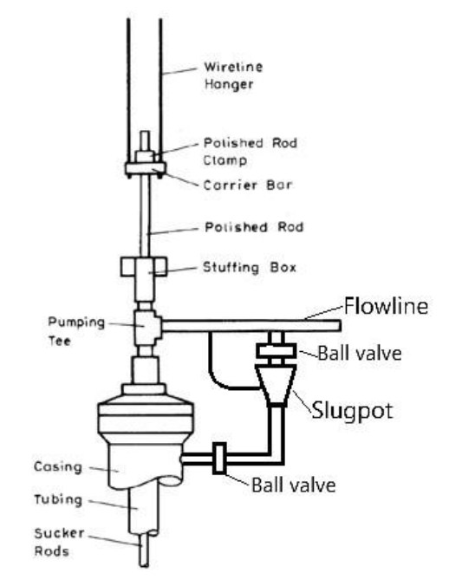
• Dropping the Pellets Step 1
Pellets are added at the slug pot (treating pot/ batch pot) and flushed down the back side of the tubing.

Can also be attached at casing at a 45 Degree angle.

.

Can also be attached at casing at a 45 Degree angle
BATCH POT

2 0r 3 Inch Full Port Ball Valves

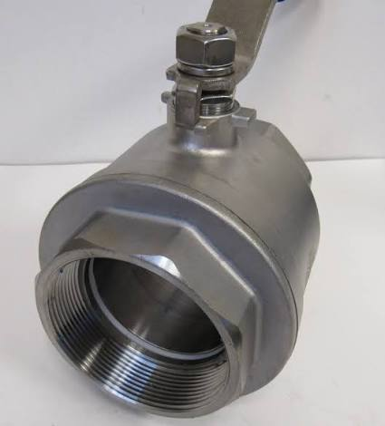 One each end

4 “x15” Threaded Each end(Threaded to accept FULL PORT Ball valves Reducer Nipple Each End.)

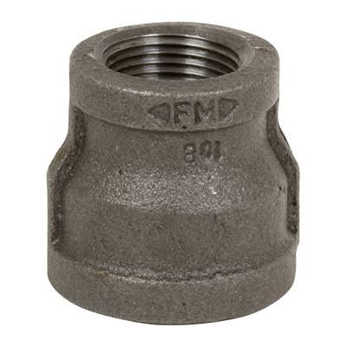Reducer Nipple

4” (Pipe to 3 “Ball Valve)

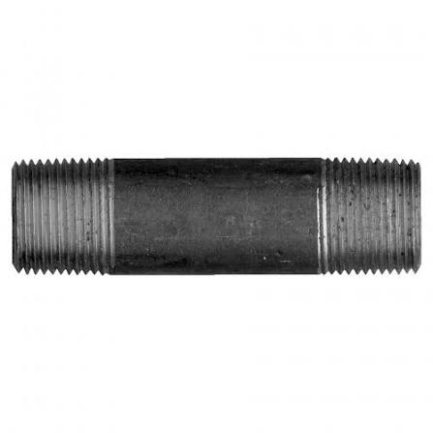{Vessel}

4” Pipe 15 to 18 Inches in length Threaded Both

Chemical batch treating pots (often called chemical injection pots or bypass feeders) are pressurized vessels used in the oil and gas industry to introduce chemical batches—such as corrosion inhibitors, biocides, or scale inhibitors—directly into a flow line.
Here is how a standard batch pot system works on a flow line using ball valves:
System Component Setup
- The Batch Pot (Vessel): A small vertical pressure vessel rated for the flow line's operating pressure. It features a top fill port for adding chemicals, a bottom drain, and top/bottom process connections.
- The Main Flow Line: The primary pipe carrying production fluids (oil, gas, water).
- Isolation Ball Valves: Typically, three main ball valves handle the chemical isolation and injection process:
  - Upstream Injection Valve: Connects the high-pressure side of the flow line to the top of the pot.
  - Downstream Return Valve: Connects the bottom of the pot back to a lower-pressure point on the flow line (or across an orifice/restriction).
  - Main Line Bypass Valve: Sits on the main flow line between the upstream and downstream pot connections.

Standard Operating Procedure (SOP)

[ Top Fill Valve ]
|
Upstream ----> [ Pot ] ----> Downstream
Ball Valve [_______] Ball Valve

| |
-----*--------[ Bypass Valve ]-------*-----> Flow Line

- Isolation & Depressurization: Close the upstream and downstream injection ball valves. Slowly open the vent and drain valves to completely empty and depressurize the pot.
- Chemical Loading: Close the drain valve. Pour the chemical batch into the top fill port, then securely close the fill port and vent valves.
- Equalization: Slowly open the upstream ball valve to pressurize the pot to line pressure. Check for leaks.
- Injection Execution: Open the downstream ball valve. Sightly pinch (partially close) the main line bypass valve. This creates a pressure drop across the bypass, forcing a portion of the main production fluid up through the pot, displacing the chemical batch cleanly into the flow line.
- Return to Normal: Once the chemical is flushed, fully reopen the main line bypass valve and close both the upstream and downstream pot ball valves.

